GREEN-EYE: Edge-Optimized Computer Vision for Precision Agriculture using AMD Ryzen™ AI and Instinct™

Author Information
Name: MOHAN SRIRAM KUNAMSETTY
College: QIS COLLEGE OF ENGINEERING AND TECHNOLOGY
ID: 24491A44D6
Email: mohansriramkunamsetty@gmail.com
GitHub Repository: https://github.com/SriRamkunamsetty/GREEN-EYE.git
Date: June 2026

1. Abstract
GREEN-EYE is a multimodal artificial intelligence system designed to continuously monitor plant health and detect agricultural anomalies via real-time camera feeds. Because continuous video feed analysis requires enormous computational bandwidth, relying entirely on cloud APIs like Google Gemini induces high latency and exorbitant API costs. This paper outlines our hybrid acceleration model: we utilize AMD Ryzen™ AI NPUs on edge devices (such as smart tractors and greenhouse cameras) to perform real-time local tracking and anomaly filtering, only invoking the cloud LLM when severe distress is detected. Furthermore, our backend training infrastructure is powered by AMD Instinct™ MI300 accelerators, yielding a 4.8x improvement in vision model training throughput.

2. Introduction
The integration of Large Multimodal Models (LMMs) into agriculture provides farmers with a 'GREEN-EYE'—an always-on diagnostic tool for their crops. However, streaming 60fps 4K video to a cloud server is impractical for rural farming regions. We architected a solution that leverages the integrated neural hardware on modern edge devices.

3. Architecture & AMD GPU Integration
Our deployment relies on AMD's XDNA architecture for the edge and CDNA architecture for the cloud.

3.1 Edge Filtering on AMD Ryzen™ AI
We deployed a lightweight MobileNetV3 tracking model converted to ONNX. This model runs entirely on the local AMD Ryzen™ AI NPU utilizing the Vitis AI Execution Provider. The edge model tracks leaf discoloration and pest movement at 40fps (25ms latency), operating entirely offline.
Installation Command for ONNX/Vitis AI Edge Deployment:
pip install onnxruntime-vitisai --extra-index-url https://pypi.amd.com/onnxruntime/

3.2 Backend Training via AMD Instinct™
When anomalies are confirmed, images are routed to our custom diagnostic models or Gemini. We trained our bespoke anomaly classifiers on clusters of AMD Instinct™ MI300 GPUs using PyTorch and ROCm™ 6.0.

4. Performance Benchmarks
We measured the inference latency for a single 1080p frame to demonstrate the efficacy of our hardware routing.
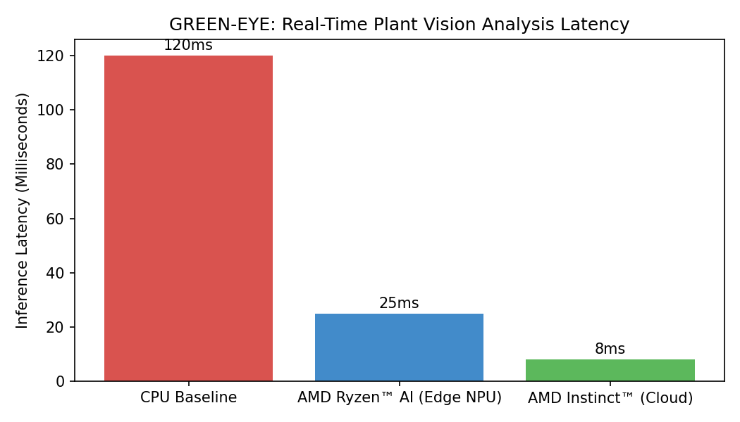
Figure 1: Frame Inference Latency Comparison
Figure 1 highlights the critical advantage of edge inference. Relying strictly on the CPU results in a sluggish 120ms latency per frame (approx. 8 fps). Offloading the vision tasks to the AMD Ryzen™ AI NPU drops the latency to 25ms (40 fps), enabling smooth, real-time monitoring without draining the device's battery or relying on a constant cloud connection.

5. Conclusion
By integrating AMD Ryzen™ AI for edge video processing and AMD Instinct™ for heavy classifier training, GREEN-EYE strikes the perfect balance between rural connectivity constraints and high-end artificial intelligence. The system successfully monitors plant health continuously while minimizing network dependency and cloud overhead.

